Parenting and Anxiety

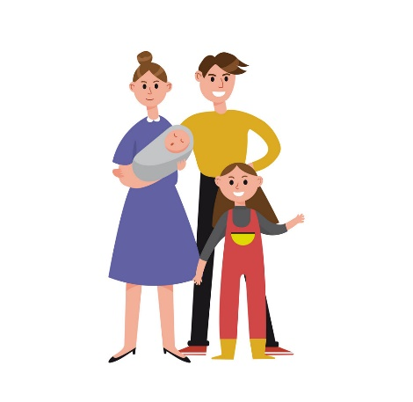
We are noticing a trend up in children and adolescents being referred to counseling services for anxiety. There are three main factors that lead to anxiety:

THOUGHTS
EMOTIONS
BEHAVIORS
Our role as parents is to understand the true reason for the anxiety. What thoughts are they having? What are they feeling? What behaviors are they showing? As parents we are the people our children look up or even imitate. We must be careful with the example we are giving our children.

Reflection.

I am responsive to my child’s feelings and needs. 1 2 3 4 5 6 7 8 9 10
I encourage my child to talk about his/her feelings and problems. 1 2 3 4 5 6 7 8 9 10
I explain the reason behind my expectations. 1 2 3 4 5 6 7 8 9 10
I provide comfort and understanding when my child is upset. 1 2 3 4 5 6 7 8 9 10
I use threats as form of punishment. 1 2 3 4 5 6 7 8 9 10
I remind my child of all the things I am doing for him/her. 1 2 3 4 5 6 7 8 9 10
I spoil my child. 1 2 3 4 5 6 7 8 9 10
I ignore my child bad behavior. 1 2 3 4 5 6 7 8 9 10
I give into my child when he/she causes a commotion about something. 1 2 3 4 5 6 7 8 9 10

